Healthier General Tso’s Chicken

* [Nutrition](http://www.teambeachbody.com/teambeachbodyblog/category/nutrition)

* [Recipes](http://www.teambeachbody.com/teambeachbodyblog/category/nutrition/recipes)

January 6, 2015

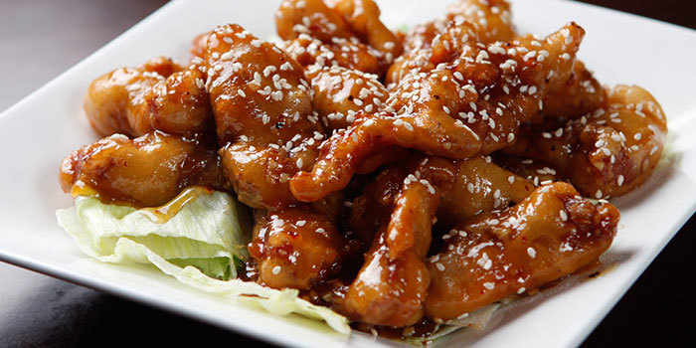

Order General Tso’s out and get ready for a hefty helping of saturated fat and calories. Try this healthier version instead and enjoy the taste and just 183 calories per serving.  
**Total Time:**25 min.  
**Prep Time:**10 min.  
**Cooking Time:**15 min.  
**Yield:**4 servings

**Ingredients:**  
1 lb. raw chicken breast, boneless, skinless, cut into 2-inch pieces  
2 Tbsp. + 1 tsp. cornstarch, divided use  
¼ tsp. sea salt  
1 tsp. sesame oil  
2 cloves garlic, finely chopped  
1 thin slice fresh ginger, peeled, finely chopped  
2 Tbsp. reduced-sodium soy sauce  
½ cup low sodium chicken broth  
1 Tbsp. rice wine vinegar  
2 Tbsp. tomato paste, no added sugar  
2 tsp. hoisin sauce  
1 tsp. pure maple syrup (or raw honey)  
2 Tbsp. cold water  
2 green onions, sliced  
1 Tbsp. toasted sesame seeds  
1 Tbsp. dried Thai chilies (optional)

**Preparation:**  
1. Preheat oven to 375° F.  
2. Line baking sheet with parchment paper; set aside.  
3. Place chicken, *2 Tbsp.* cornstarch, and salt in a medium bowl; toss until well coated.  
4. Place chicken in a single layer on prepared baking sheet; bake for 12 to 15 minutes, or until cooked through.  
5. While chicken is baking, heat oil, garlic, and ginger in large skillet over medium heat; cook for 1 to 2 minutes.  
6. Add soy sauce, broth, vinegar, tomato paste, hoisin sauce, and maple syrup. Bring to a boil. Reduce heat to medium-low; cook for 4 to 5 minutes.  
7. Dissolve *remaining 1 tsp.* cornstarch in cold water; add to soy sauce mixture. Gently boil, stirring frequently, for another 3 to 4 minutes, or until sauce begins to thicken.  
8. Add cooked chicken to sauce, coating thoroughly.  
9. Serve chicken sprinkled with sesame seeds, green onions, and chilies (if desired).

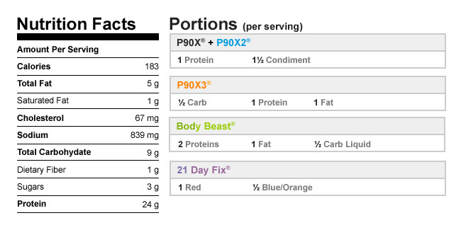

Authors

[Beachbody](http://www.teambeachbody.com/teambeachbodyblog/author/beachbody)

Tags[chicken](http://www.teambeachbody.com/teambeachbodyblog/tag/chicken), [dinner](http://www.teambeachbody.com/teambeachbodyblog/tag/dinner), [high protein](http://www.teambeachbody.com/teambeachbodyblog/tag/high-protein), [lunch](http://www.teambeachbody.com/teambeachbodyblog/tag/lunch), [recipes](http://www.teambeachbody.com/teambeachbodyblog/tag/recipe)

RELATED POSTS